Job Description/Person Spec for a Personal Assistant

Are you lively and energetic? Do you have a sense of fun and adventure?
Do you enjoy working with young people?...

If so, you could be the person that we are looking for.
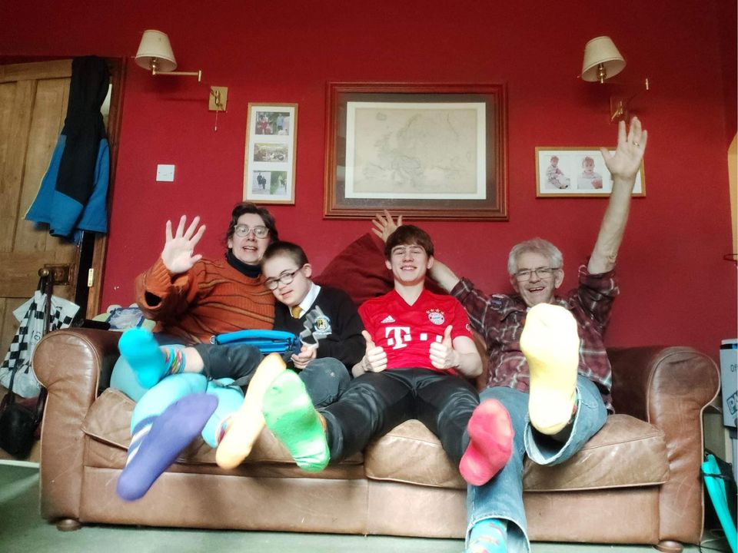
We are the proud parents of two fantastic sons aged 18 and 15. Our younger son is cheeky, lively and knows what he likes. We are looking for an assistant to support him to socialise, develop friendships and enjoy life in our local community. This role is required because he has a learning disability (due to Autism and Down Syndrome) and is unable to verbally communicate or keep himself safe. Because of these disabilities, our family receive a small personal budget so that he can have some time doing fun things without us, helping him develop independence from the rest of his family.

Like many 15-year-olds, he has a great sense of fun but also likes space to himself in his room. He is particularly keen to seek sensory regulation in his play on swings, slides and trampolines. He is also very keen on technology and loves to use an iPad to entertain himself. In general, our son is a laid back and cheerful character, however he likes predictability. Understandably, he can get upset and frustrated if things aren’t as he expects, or if he is unable to make his wants understood. We are looking for the right person who will enjoy having fun, seek to understand his needs and be persistent in expectations of behaviour. You will be willing to attend specialist training to support the role if this is required.

These are some of the things that he may need support with:

- Communication using Makaton and/or an AAC app on his ipad
- Visits to the toilet and changing soiled nappies if required and support with toilet training.
- Support to use cutlery including cutting up food if out for a meal/snack
- Support to make appropriate choices in everyday life; e.g. selecting food
- Cleaning face/hands after eating if necessary
- Going to the park and supporting on play equipment
- Going on bike/trike rides
- Playing football or other organised group sports or afterschool activity
- Depending on the flexibility or situation of the PA, the role could potentially also:
  - provide 1to1 support on a one-off basis when he socialises with friends
  - accompany the family on outings – or even weekends away
  - provide care for him within your own home
  - provide care at the family home supporting activities on his iPad, sharing/reading books, participating in zoom activities, play in the garden or craft activities.

We are looking for a person who is;

- Reliable, punctual and trustworthy
- Able to be flexible with regards to working times
- Friendly and easy going with a sense of humour
- Happy to cope with a cluttered, and untidy environment (at the family home)
- Comfortable around animals at the family home (We have a dog, chickens, and a guinea pig)
- Non-smoker whilst with all members of our family
- Keen to develop their learning, experience and knowledge

And who will ideally have;

- The ability to travel to the family home near Crockey Hill south of York (desirable but not essential as we can arrange to pick up from a local bus stop or meet up for specific activities)
- A full clean driving licence and willing to drive either their own car or a family car for the purposes of this role (desirable but not essential)
- Experience of using makaton sign language and AAC communication (desirable but not essential)
- Experience of working with children (paid or unpaid – highly beneficial but not essential)
- Links within local communities near our home Wheldrake, Thorganby, Elvington, Escrick, Naburn, Fulford. (Beneficial but not essential)

The Post
The post is very flexible, but as a guide we would hope to employ the PA on a flexible basis for up to 3 hours per week or 6 hours per fortnight at times to be agreed. These times would likely to be either after school, on an evening, at the weekend or during school holidays.

Rate of pay is currently £12 per hour. This is the current City of York Council Personal Budget rate that our allocated budget allows. We believe the input required potentially merits more than is allocated and are keen to employ the right person on an appropriate rate of pay. If we can identify an experienced person who meets our brief, we are willing to explore any available options to improve the pay rate. We are however unable to negotiate on this with the council until we have identified a potential PA who has relevant experience/expertise.

Please feel free to informally enquire about the post if the job itself if is at all appealing. Please don’t be put off if you don’t meet all the “desirable/ideal” criteria!

